**MINI PROJECT REPORT – 2025**  
**E-commerce Cart System using Arrays & SQL Inventory**  
Submitted in partial fulfillment of the requirements of  
**[Software Development / B.Sc Computer Technology ]**

**Submitted By:**

**Team Name:** Buggy Bug

**Class:** III - B.SC CT ‘A’ ,’B’

**Date of Submission:** 28/06/2025

**Team Details**

|  |  |  |  |
| --- | --- | --- | --- |
| **S. No** | **Name** | **Roll Number** | **Role** |
| 1 | Aishwarya Devi R | 2326KB02 | Leader |
| 2 | Harshini S | 2326KA16 | Developer |
| 3 | Deepakkumar R | 2326KA09 | Tester |
| 4 | Parama Dharshini H | 2326KA32 | Documenter |
| 5 | Sabthami S | 2326KA42 | Presenter |

## A logo with text on it AI-generated content may be incorrect.Declaration

We hereby declare that the project entitled “**E-commerce Cart System using Arrays & SQL Inventory”** submitted in partial fulfillment of the requirements for the course  **Software Development** is a **record of our original work** carried out under the guidance of, Technical Trainer, Technical Department, KGiSL Microcollege.

We further declare that this project has not been submitted previously, either in part or in full, for the award of any degree, diploma, or other similar title, at this or any other institution.

We have acknowledged all sources of information used in this project wherever applicable.

**Team Members:**

|  |  |  |  |
| --- | --- | --- | --- |
| **S. No.** | **Name** | **Roll Number** | **Signature** |
| 1. | Aishwarya Devi R | 2326KB02 |  |
| 2. | Harshini S | 2326KA16 |  |
| 3. | Deepakkumar R | 2326KA09 |  |
| 4. | Parama Dharshini H | 2326KA32 |  |
| 5. | Sabthami S | 2326KA42 |  |

**Place: Coimbatore**

**Date:**  28.06.2025

**Certificate**

This is to certify that the project entitled “**E-commerce Cart System using Arrays & SQL Inventory”** is a **bona fide work** carried out by the following students of **III- B.Sc CT ‘A’ & ‘B’**, **Computer Technology**,  **KG College of Arts and Science**,  in partial fulfilment of the requirements for the course **Software Development.**

This project has been completed under my supervision and guidance during the academic period **June/2025.**

It is further certified that this project is the **original work** of the students and has not been previously submitted for the award of any degree, diploma, or certificate at this or any other institution.

**Project Team:**

|  |  |  |
| --- | --- | --- |
| **S. No.** | **Name** | **Roll Number** |
| 1. | Aishwarya Devi R | 2326KB02 |
| 2. | Harshini S | 2326KA16 |
| 3. | Deepakkumar R | 2326KA09 |
| 4. | Parama Dharshini H | 2326KA32 |
| 5. | Sabthami S | 2326KA42 |

**Guide:   Head of the Department  
(Technical Trainer, KGM)               (Technical Head, KGM)**

______________________                                                     _______________________

**Place:** Coimbatore

**Date: 28.06.2025**

## Abstract

The main goal of this project is to develop a basic E-commerce Cart System that allows users to browse, select, and manage products in a shopping cart. The system ensures real-time updates and validation using an inventory managed through SQL, while product selection and cart handling are managed using arrays.

## Objective

## The objective of the “E-commerce Cart System using Arrays & SQL Inventory”is to simulate the core functionality of an online shopping platform by allowing users to add, remove, and update items in a shopping cart. This project addresses the problem of managing temporary cart data and ensuring real-time synchronization with available product inventory. It uses arrays to handle cart operations efficiently and integrates an SQL database to manage product inventory, ensuring that stock levels are accurately reflected during user interactions

## Problem Statement

• Cart updates are not real-time, leading to confusion over selected items and pricing.

• Arrays efficiently manage temporary cart data during user sessions.

• SQL database provides accurate, real-time inventory tracking and updates.

• Overall, it streamlines the shopping process for a better user experience.

**Scope of the Project**

• Product listing fetched from an SQL database

• Adding, removing, and updating items in the cart using arrays

• Inventory validation (ensures products are in stock before adding to cart)

• Simple checkout process with inventory update upon purchase

**Technology Stack**

|  |  |
| --- | --- |
| **Layer/Component** | **Technology Used** |
| Programming | Java (JDK 17 or later) |
| Database | MySQL |
| DB Connectivity | JDBC |
| IDE | Eclipse / IntelliJ IDEA |

## System Design & Architecture

## User (Console Input) 🡪 Cart Management (Arrays) 🡪 Inventory Check / Update

## (SQL Database) 🡪 Checkout & Inventory Adjustment

## Modules Description

## 1. DBConnection.java (db/) – Handles MySQL database connections and executes CRUD operations for inventory management.

## 2. Product.java (model/) – Defines the product data structure (ID, name, price, stock) as a DTO for database interactions.

## 3. AdminService.java (service/) – Manages admin-only functions like adding, updating, or deleting products in the inventory.

## 4. CartService.java (service/) – Implements cart operations (add/remove/update) using arrays and validates stock via SQL.

## 5. ProductService.java (service/) – Fetches product listings and checks real-time inventory availability from the database.

## 6. Main.java (ui/)– Drives the console UI, displays menus, and routes user inputs to appropriate services.

## 7. Cart System (Arrays) – Temporarily stores cart items in-memory with fast array operations during user sessions.

## 8. SQL Inventory (MySQL) – Maintains product stock levels and syncs with cart operations to prevent overselling.

## 9. Checkout System – Finalizes purchases, updates SQL inventory, and generates order summaries.

## DSA Folder Structure

## EcommerceCartSystem/

## ├── src/

## │ ├── db/

## │ │ └── DBConnection.java # Database connection handler

## │ ├── model/

## │ │ └── Product.java # Product data model

## │ ├── service/

## │ │ ├── AdminService.java # Admin product management

## │ │ ├── CartService.java # Cart operations

## │ │ └── ProductService.java # Product listing services

## │ ├── ui/

## │ │ └── Main.java # Main application entry point

## │ ├── Referenced Libraries/ # External dependencies

## Implementation Details

• **Data Structure:** Arrays manage cart items during the session for fast add, update, and delete operations.

• **SQL Database:** Stores product details and inventory; supports CRUD operations to fetch, update, and maintain stock levels.

• **Logic:** Uses simple search on arrays to locate cart items; SQL queries handle inventory checks and updates.

## Sample Screenshots / Outputs

## 

## 

## 

## Testing & Validation

• **Unit Testing:** Cart functions (add/update/delete) were tested with sample inputs and validated against expected outputs.

• **SQL Verification:** Inventory updates were checked by querying stock before and after checkout.

• **Integration Testing:** End-to-end tests ensured correct interaction between arrays and SQL for accurate cart and inventory behaviour.

## Challenges Faced

• **Array Index Out of Bounds:**  
Happened when updating or removing non-existent items from the cart.  
Resolved by : Validating index ranges and checking item existence before operations.

• **Inventory Mismatch:**  
Stock levels in the cart didn’t match SQL inventory.  
Resolved by : Validating inventory before each cart update and after checkout.

**Learnings**

• Applied arrays for efficient cart item handling.

• Designed and managed SQL tables with proper CRUD operations.

• Improved code structure, debugging, and validation skills.

• Strengthened teamwork through task coordination and clear communication.

## Conclusion

## The E-commerce Cart System was successfully implemented as a console-based application. It allows users to manage cart items using arrays and maintains accurate inventory through SQL integration. The system meets its objective by automating cart operations.

## References

• W3Schools – SQL Tutorial

• GeeksforGeeks – Data Structures (Arrays)

• JavaTPoint – E-commerce System Design Basics

• Class notes and instructor guidance

**Appendix**

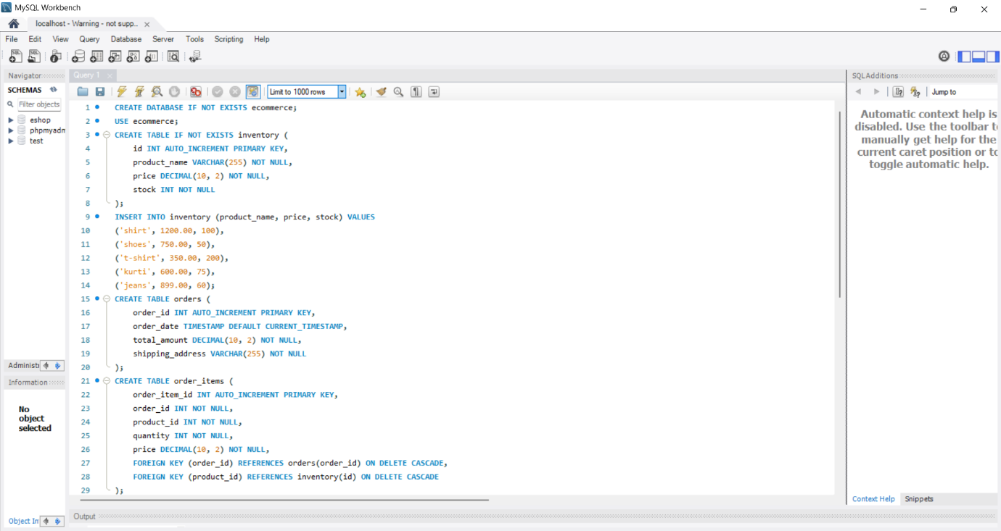

Database( schema.sql)